**SACRED HEART GIRLS’ COLLEGE**

**OAKLEIGH**

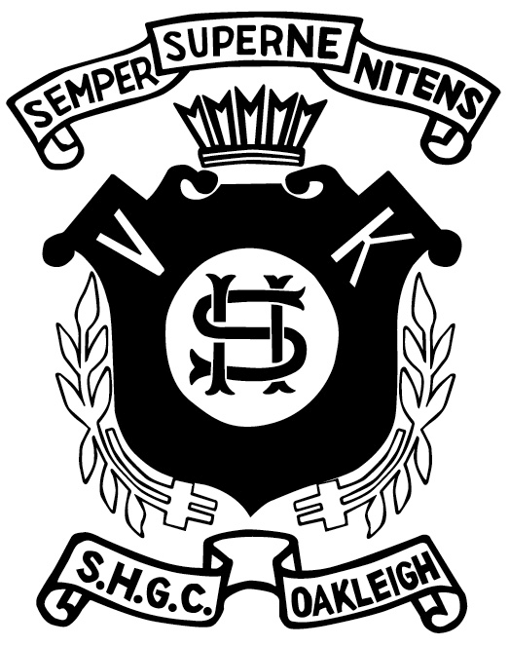

**Mathematical Methods CAS 2014**

**Unit 3 SAC 1: TEST**

**Part A**

**Name: ________________________________**

**Teacher (please circle)**: Ms Gates Mr Smith Ms Garkel

**No CAS and no summary notes permitted**

**Part A: 3 short answer questions**

**Writing Time: 20 minutes**

**Marks: 15**

**SHORT ANSWER QUESTIONS**

**Instructions:**

Answer **all** questions in the spaces provided.

In all questions where a numerical answer is required an exact value must be given unless otherwise specified.

In questions where more than one mark is available, appropriate working **must** be shown.

Unless otherwise indicated, the diagrams in this test are **not** drawn to scale.

**Question 1** (7 marks)

Consider the function $f:D→R, f\left(x\right)=3-\sqrt{2x+4}$, where $D$ is the maximal domain of $f.$

1. Find $D$. 1 mark
2. Describe the transformations which when applied to the graph of $y=\sqrt{x}$, produce the graph of $y=f(x)$. 2 marks
3. Find the rule for $f^{-1}$, the inverse of $f$. 2 marks
4. Show that the values of $x$ for which $f\left(x\right)=x$ and hence the values of $x$

for which $f\left(x\right)=f^{-1}(x)$ are $x=4±\sqrt{11}$. 2 marks

**Question 2** (4 marks)

For $f\left(x\right)=\sqrt{x+3}-1$ and $g\left(x\right)=|x|+2$

1. Find the rule for $g\left(f\left(x\right)\right)$. 1 mark
2. Write the rule for $g\left(f\left(x\right)\right)$ as a hybrid function and state the domain. 3 marks

**Question 3** (4 marks)

1. For the function $\left(x\right)=\frac{x+3}{x+2}$, write the function in the form $f\left(x\right)=a+\frac{b}{x+2}$. 2 marks
2. Hence, find $g(x)$ if $g\left(x\right)=f^{-1}(x)$. 2 marks

**END OF QUESTION AND ANSWER BOOKLET**